THE RUSSON AND PECK PIONEER MONUMENT
May 18, 2009, Carl Mellor representing the Lehi Chapter of Sons of Utah Pioneers came
to Ron Peck and Stanford Russon and suggested the erection of a monument in memory of
the Peck and Russon immigration to Utah. They would be in charge of raising the funds,
and overseeing the project. He explained that the main message was the gift given to those,
our forefathers, of a new religion and philosophy of life, and material help to come here,
then the rewards and services they rendered in return would be the purpose of the work.
Mr. Mellor had already planned a system of selling tickets to present to family members,
now four generations since, for a great banquet to be held July 13.
This ticket selling task seemed overwhelming with the thousands of descendents, some
scattered far away. But the response was gratifying. Though, these were hard times
financially, we found our relatives to be enthusiastic, liberal and generous. It was a sweet
visit with people we had not seen for many years and we came home rejoicing
The banquet, July 13 included Pecks, Russons and Christoffersons, whose pioneers and
decedents have mingled here together in Lehi these past 200 years. (the Christofferson
monument is separate from Russon and Peck). Two hundred seventy five people attended.
The dinner was donated by Carl Mellor. The speakers were representatives of the families
and a guest speaker, Gene R. Cook, Seventy emeritus of the L.D.S. Church. It was an exciting
celebration.
Mr. Mellor had suggested that each family should raise $1000. The income for the Russon
and Peck project was $3800, for which we rejoiced. We decided to put a large plaque on
front giving the history and statements noted above, and another smaller plaque on back
describing the land and agricultural development on it.
Stan Russon hunted for an appropriate stone and finally found the appropriate one, an
onyx six inches thick with smooth faces both sides and ordered it June 16.
The work of designing the plaques was tremendous. The story of their relationship through
marriage and neighboring borders must be accurately told as well as the awesome new life
in virgin land and their commitment to their church. We had some excellent photographs of
Elisha Peck Sr. and Charlotte Russon, whose marriage bonded the two families, also two
family pictures of the Russons with ten children and a parallel of next generation Pecks with
ten children. One picture of Lott Sr. and his wife at the mine reading to him the letter which
promised their fare to Utah was rendered earlier for another history, and another of the
Russons sorting onions were made by Stan Russon. This effort lasted for several months.
The location of this monument should obviously be on actual land of our forefathers as
well as apparent to public view. That happened to be on city-owned property. The mayors
and city council were congenial, but had to write up a code to cover the agreement and the
permit was given October 7, 2009
Now this permit required that the text on the plaques would have to be approved by the
Lehi Historical Society. That editing took six months sifting out the references to religion
that might be objected by the secular people. The final draft was approved May 11, 2010.
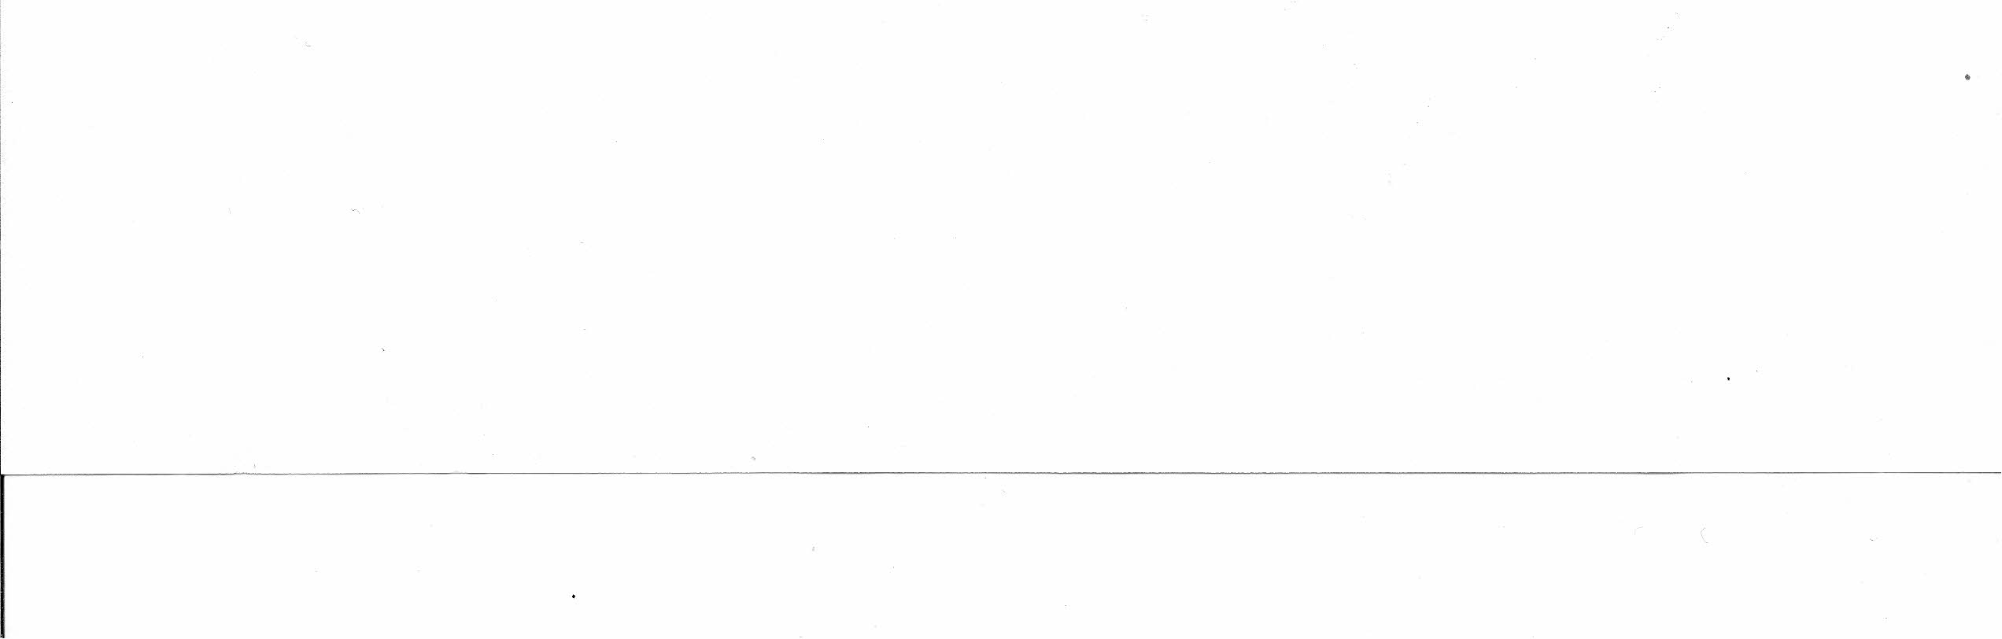
By that time, we found that our stone had been sold, but another larger and more costly
was available. With that small variance, the whole deal was presented to the City Council
in session on May 11, 2010, and on May 17, Mark Johnson of the council said, "It is
cleared, Go to work."
LaVell and Ron Russon hauled the stone weighing one and one half tons to Lehi June 2,
2010. Ron Peck ordered his concrete contractors to set it up in concrete June 15. They did
an excellent job.
Carl Mellor and Stan Russon presented the final information for the plaques to Graphics
Signs and Systems, John Peters, with original pictures and approved text June 17,2010.
Final approval was accepted July 9th• Now again was an anxious wait, and finally
September 20, 2010, Carl Mellor and Stan Russon picked up the finished plaques.
These plaques were installed on the monument stone September 21 by LaVell,
Ron and Stan Russon. The onyx was very hard. It burnt up several hammer drill bits, but
should last a long, long time.
The dedication ceremony was scheduled for October 30 at the site at 1 :00 P.M. Programs
were put together by Stan Russon and many sent out to contributors. The week before the
dedication was stormy and cold. LaVell Russon and Elwyn Peck suggested and made
arrangements for meeting in a room at the L.D.S. chapel one half block away from the site
where there was sufficient parking, warmth, music and P.A. system which made the
assembly much more enjoyable.
Val Tucker, President of Lehi Chapter of Sons of Utah Pioneers conducted the meeting.
Speakers were Carl Mellor and Stan Russon, then the congregation sang "They The
Builders Of The Nation" led by Lornell Bateman accompanied by Norma Peck, Ron Peck
was final speaker. The gathering which amounted to more than on hundred people then
moved to the monument site for the Prayer of Dedication by President Randy Russon. A
photo of the entire group was made by Chapter President-Elect, Jay Larson.
Written by Stanford D. Russon November 2, 2010

